/

**Mobile Applications Development**

**Task # 01**

**Course Instructor:** Muhammad Ahmed  **Total Marks: 10**



Student Name: Muhammad Haroon

Q1: Implement the following layout design into Relative and constraint with help of XML. You can use back ground wall paper as well.

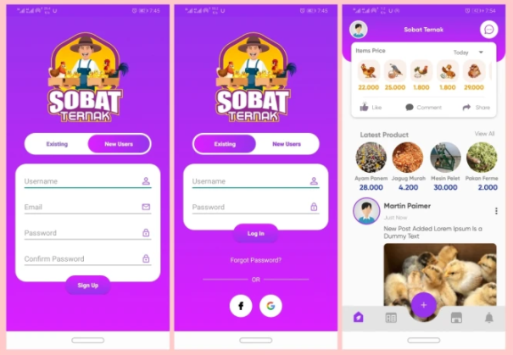

**,,,,,,,,,,,,,,,,,,,,,,,,,,,,,,,,,,,,,,,,,,,,,,,,,,,,,,,,,,,,,,,,,,,,,,,,,,,,,,,,,,,,,,,,,,,,,,,,,,,,,,,,,,,,,,,,,,,,,,,,,,,,,,,**

Solution:

**Front End**

**First Page:**

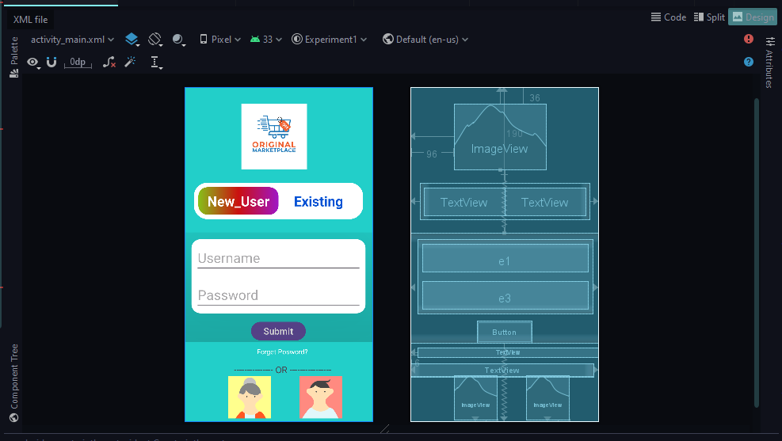

**Second Page:**

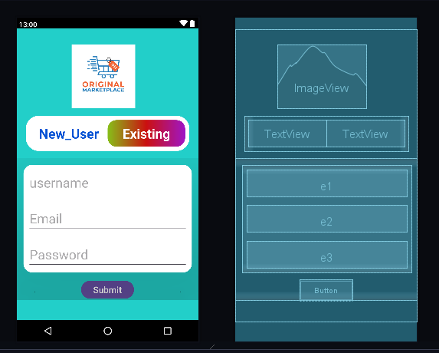

**Third Page:**

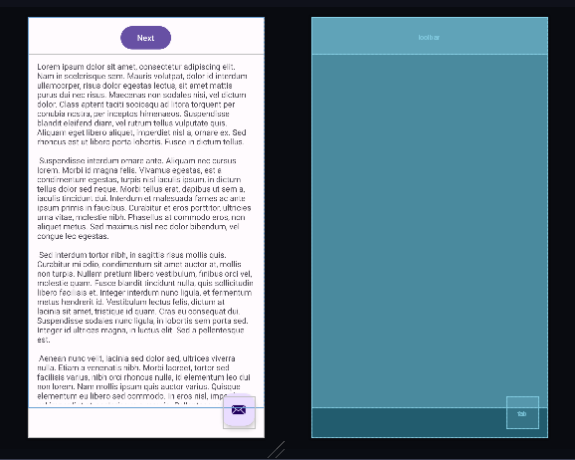

**Xml Code:**

**First Page:**

<?*xml version*="1.0" *encoding*="utf-8"?>  
<androidx.constraintlayout.widget.ConstraintLayout *xmlns:android*="http://schemas.android.com/apk/res/android"  
 *xmlns:app*="http://schemas.android.com/apk/res-auto"  
 *xmlns:tools*="http://schemas.android.com/tools"  
 *android:layout_width*="match_parent"  
 *android:layout_height*="match_parent"  
 *android:background*="#22CFC9"  
 *android:orientation*="vertical"  
 *tools:context*=".MainActivity">  
  
 <ImageView  
 *android:id*="@+id/imageView2"  
 *android:layout_width*="200dp"  
 *android:layout_height*="144dp"  
 *android:layout_marginStart*="96dp"  
 *android:layout_marginLeft*="96dp"  
 *android:layout_marginTop*="36dp"  
 *android:src*="@drawable/lg1"  
 *app:layout_constraintStart_toStartOf*="parent"  
 *app:layout_constraintTop_toTopOf*="parent" />  
  
 <LinearLayout  
 *android:layout_width*="match_parent"  
 *android:layout_height*="wrap_content"  
 *android:layout_margin*="20dp"  
 *android:background*="@drawable/curve_bac"  
 *android:orientation*="horizontal"  
 *android:padding*="10dp"  
 *app:layout_constraintBottom_toTopOf*="@+id/linearLayout2"  
 *app:layout_constraintEnd_toEndOf*="parent"  
 *app:layout_constraintStart_toStartOf*="parent"  
 *app:layout_constraintTop_toBottomOf*="@+id/imageView2"  
 *app:layout_constraintVertical_bias*="0.5">  
  
 <TextView  
 *android:layout_width*="match_parent"  
 *android:layout_height*="wrap_content"  
 *android:layout_weight*="1"  
 *android:background*="@drawable/background"  
 *android:gravity*="center_horizontal"  
 *android:padding*="10dp"  
 *android:text*="New_User"  
 *android:textAlignment*="center"  
 *android:textColor*="#ffff"  
 *android:textSize*="30dp"  
 *android:textStyle*="bold">  
  
 </TextView>  
  
 <TextView  
 *android:layout_width*="match_parent"  
 *android:layout_height*="wrap_content"  
 *android:layout_weight*="1"  
 *android:gravity*="center_horizontal"  
 *android:padding*="10dp"  
 *android:text*="Existing"  
 *android:textAlignment*="center"  
 *android:textColor*="#0452D4"  
 *android:textSize*="30dp"  
 *android:textStyle*="bold">  
  
 </TextView>  
 </LinearLayout>  
  
 <LinearLayout  
 *android:id*="@+id/linearLayout2"  
 *android:layout_width*="match_parent"  
 *android:layout_height*="wrap_content"  
 *android:layout_marginTop*="190dp"  
 *android:orientation*="vertical"  
 *app:layout_constraintBottom_toBottomOf*="parent"  
 *app:layout_constraintEnd_toEndOf*="parent"  
 *app:layout_constraintHorizontal_bias*="0.0"  
 *app:layout_constraintStart_toStartOf*="parent"  
 *app:layout_constraintTop_toTopOf*="parent"  
 *app:layout_constraintVertical_bias*="0.425">  
  
 <androidx.cardview.widget.CardView  
 *android:layout_width*="match_parent"  
 *android:layout_height*="wrap_content"  
 *android:layout_margin*="15dp"  
 *app:cardCornerRadius*="20dp"  
 *app:cardElevation*="200dp">  
  
 <LinearLayout  
 *android:layout_width*="match_parent"  
 *android:layout_height*="wrap_content"  
 *android:orientation*="vertical">  
  
  
 <EditText  
 *android:id*="@+id/e1"  
 *android:layout_width*="match_parent"  
 *android:layout_height*="wrap_content"  
 *android:layout_margin*="10dp"  
 *android:hint*="Username"  
 *android:textSize*="30dp">  
  
 </EditText>  
  
  
 <EditText  
 *android:id*="@+id/e3"  
 *android:layout_width*="match_parent"  
 *android:layout_height*="wrap_content"  
 *android:layout_margin*="10dp"  
 *android:hint*="Password"  
 *android:textSize*="30dp">  
  
 </EditText>  
  
  
 </LinearLayout>  
  
 </androidx.cardview.widget.CardView>  
  
 <Button  
 *android:layout_width*="120dp"  
 *android:layout_height*="wrap_content"  
 *android:layout_gravity*="center"  
 *android:text*="Submit"  
 *android:textSize*="20dp">  
  
 </Button>  
  
 </LinearLayout>  
  
 <TextView  
 *android:layout_width*="match_parent"  
 *android:layout_height*="wrap_content"  
 *android:layout_marginStart*="16dp"  
 *android:layout_marginLeft*="16dp"  
 *android:gravity*="center"  
 *android:text*="Forget Posword?"  
 *android:textColor*="@color/white"  
 *android:textSize*="15dp"  
 *app:layout_constraintStart_toStartOf*="parent"  
 *tools:layout_editor_absoluteY*="569dp" />  
  
 <LinearLayout  
 *android:layout_width*="400dp"  
 *android:layout_height*="30dp"  
 *android:orientation*="horizontal"  
 *app:layout_constraintEnd_toEndOf*="parent"  
 *app:layout_constraintHorizontal_bias*="0.0"  
 *app:layout_constraintStart_toStartOf*="parent"  
 *tools:layout_editor_absoluteY*="605dp">  
  
 <TextView  
 *android:layout_width*="match_parent"  
 *android:layout_height*="wrap_content"  
 *android:paddingHorizontal*="15dp"  
 *android:text*=" --------------- OR ----------------"  
 *android:textAlignment*="center"  
 *android:textSize*="20dp">  
  
 </TextView>  
 </LinearLayout>  
<LinearLayout  
 *android:layout_width*="wrap_content"  
 *android:layout_height*="wrap_content"  
 *android:orientation*="horizontal"  
  
 >  
  
</LinearLayout>  
  
 <ImageView  
 *android:id*="@+id/fb1"  
  
 *android:layout_width*="93dp"  
 *android:layout_height*="97dp"  
 *android:layout_marginBottom*="4dp"  
 *android:src*="@drawable/fb1"  
 *app:layout_constraintBottom_toBottomOf*="parent"  
 *tools:layout_editor_absoluteX*="252dp"  
 *tools:srcCompat*="@tools:sample/avatars" />  
  
 <ImageView  
 *android:id*="@+id/fb1"  
  
 *android:layout_width*="93dp"  
 *android:layout_height*="97dp"  
 *android:layout_marginBottom*="4dp"  
 *android:src*="@drawable/curve_bac"  
 *app:layout_constraintBottom_toBottomOf*="parent"  
 *tools:layout_editor_absoluteX*="96dp"  
 *tools:srcCompat*="@tools:sample/avatars"

**Second Page:**

<?*xml version*="1.0" *encoding*="utf-8"?>  
<androidx.constraintlayout.widget.ConstraintLayout *xmlns:android*="http://schemas.android.com/apk/res/android"  
 *xmlns:app*="http://schemas.android.com/apk/res-auto"  
 *xmlns:tools*="http://schemas.android.com/tools"  
 *android:background*="#22CFC9"  
 *android:orientation*="vertical"  
 *android:layout_width*="match_parent"  
 *android:layout_height*="match_parent"  
 *tools:context*=".MainActivity2">  
  
 <ImageView  
 *android:id*="@+id/imageView2"  
 *android:layout_width*="200dp"  
 *android:layout_height*="144dp"  
 *android:layout_marginStart*="96dp"  
 *android:layout_marginLeft*="96dp"  
 *android:layout_marginTop*="36dp"  
 *android:src*="@drawable/lg1"  
 *app:layout_constraintStart_toStartOf*="parent"  
 *app:layout_constraintTop_toTopOf*="parent">  
  
 </ImageView>  
 <LinearLayout  
 *android:layout_width*="match_parent"  
 *android:layout_height*="wrap_content"  
 *android:layout_margin*="20dp"  
 *android:background*="@drawable/curve_bac"  
 *android:orientation*="horizontal"  
 *android:padding*="10dp"  
 *app:layout_constraintBottom_toTopOf*="@+id/linearLayout2"  
 *app:layout_constraintEnd_toEndOf*="parent"  
 *app:layout_constraintStart_toStartOf*="parent"  
 *app:layout_constraintTop_toBottomOf*="@+id/imageView2"  
 *app:layout_constraintVertical_bias*="0.5">  
  
 <TextView  
 *android:layout_width*="match_parent"  
 *android:layout_height*="wrap_content"  
 *android:layout_weight*="1"  
 *android:gravity*="center_horizontal"  
 *android:padding*="10dp"  
 *android:text*="New_User"  
 *android:textAlignment*="center"  
 *android:textColor*="#0452D4"  
 *android:textSize*="30dp"  
 *android:textStyle*="bold">  
  
 </TextView>  
  
 <TextView  
 *android:layout_width*="match_parent"  
 *android:layout_height*="wrap_content"  
 *android:layout_weight*="1"  
 *android:gravity*="center_horizontal"  
 *android:padding*="10dp"  
 *android:background*="@drawable/background"  
 *android:text*="Existing"  
 *android:textAlignment*="center"  
 *android:textColor*="#ffff"  
 *android:textSize*="30dp"  
 *android:textStyle*="bold">  
  
 </TextView>  
 </LinearLayout>  
  
 <LinearLayout  
 *android:id*="@+id/linearLayout2"  
 *android:layout_width*="match_parent"  
 *android:layout_height*="wrap_content"  
 *android:layout_marginTop*="190dp"  
 *android:orientation*="vertical"  
 *app:layout_constraintBottom_toBottomOf*="parent"  
 *app:layout_constraintEnd_toEndOf*="parent"  
 *app:layout_constraintStart_toStartOf*="parent"  
 *app:layout_constraintTop_toTopOf*="parent"  
 *app:layout_constraintVertical_bias*="0.696">  
  
 <androidx.cardview.widget.CardView  
 *android:layout_width*="match_parent"  
 *android:layout_height*="wrap_content"  
 *android:layout_margin*="15dp"  
 *app:cardCornerRadius*="20dp"  
 *app:cardElevation*="200dp">  
  
 <LinearLayout  
 *android:layout_width*="match_parent"  
 *android:layout_height*="wrap_content"  
 *android:orientation*="vertical">  
  
  
 <EditText  
 *android:id*="@+id/e1"  
 *android:layout_width*="match_parent"  
 *android:layout_height*="wrap_content"  
 *android:layout_margin*="10dp"  
 *android:hint*="username"  
 *android:textSize*="30dp">  
  
 </EditText>  
  
 <EditText  
 *android:id*="@+id/e2"  
 *android:layout_width*="match_parent"  
 *android:layout_height*="wrap_content"  
 *android:layout_margin*="10dp"  
 *android:hint*="Email"  
 *android:textSize*="30dp">  
  
 </EditText>  
  
 <EditText  
 *android:id*="@+id/e3"  
 *android:layout_width*="match_parent"  
 *android:layout_height*="wrap_content"  
 *android:layout_margin*="10dp"  
 *android:hint*="Password"  
 *android:textSize*="30dp">  
  
 </EditText>  
  
  
 </LinearLayout>  
  
 </androidx.cardview.widget.CardView>  
  
 <Button  
 *android:layout_width*="120dp"  
 *android:layout_height*="wrap_content"  
 *android:layout_gravity*="center"  
 *android:text*="Submit"  
 *android:textSize*="20dp">  
  
 </Button>  
  
 </LinearLayout>  
  
  
</androidx.constraintlayout.widget.ConstraintLayout>  
  
  
  
  
  
  
  
  
</androidx.constraintlayout.widget.ConstraintLayout>

**Third Page:**

<?*xml version*="1.0" *encoding*="utf-8"?>  
<androidx.coordinatorlayout.widget.CoordinatorLayout  
 *xmlns:android*="http://schemas.android.com/apk/res/android"  
 *xmlns:app*="http://schemas.android.com/apk/res-auto"  
 *xmlns:tools*="http://schemas.android.com/tools"  
 *android:layout_width*="match_parent"  
 *android:layout_height*="match_parent"  
 *android:fitsSystemWindows*="true"  
 *tools:context*=".MainActivity3">  
  
 <com.google.android.material.appbar.AppBarLayout  
 *android:layout_height*="wrap_content"  
 *android:layout_width*="match_parent"  
 *android:fitsSystemWindows*="true"  
 >  
  
 <com.google.android.material.appbar.MaterialToolbar  
 *android:id*="@+id/toolbar"  
 *android:layout_width* = "match_parent"  
 *android:layout_height* = "?attr/actionBarSize" />  
  
 </com.google.android.material.appbar.AppBarLayout>  
  
 <include  
 *layout*="@layout/content_main"  
 *android:layout_width*="match_parent"  
 *android:layout_height*="678dp" />  
  
 <com.google.android.material.floatingactionbutton.FloatingActionButton  
 *android:id*="@+id/fab"  
 *android:layout_width*="wrap_content"  
 *android:layout_height*="wrap_content"  
 *android:layout_gravity*="bottom|end"  
 *android:layout_marginEnd*="@dimen/fab_margin"  
 *android:layout_marginBottom*="16dp"  
 *app:srcCompat*="@android:drawable/ic_dialog_email" />  
  
 </androidx.coordinatorlayout.widget.CoordinatorLayout>

**Colour of button:**

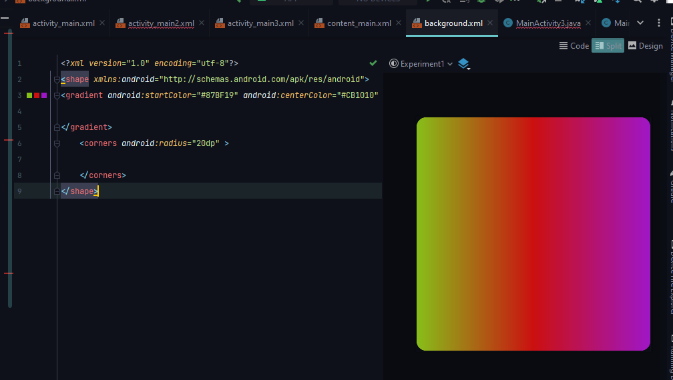

**Code:**

<?*xml version*="1.0" *encoding*="utf-8"?>  
<shape *xmlns:android*="http://schemas.android.com/apk/res/android">  
<gradient *android:startColor*="#87BF19" *android:centerColor*="#CB1010" *android:endColor*="#9F16C6" >  
  
</gradient>  
 <corners *android:radius*="20dp" >  
  
 </corners>  
</shape>

**Main Activty jawa:**

*package* com.example.experiment1;  
  
*import* android.os.Bundle;  
*import* com.google.android.material.snackbar.Snackbar;  
*import* androidx.appcompat.app.AppCompatActivity;  
*import* android.view.View;  
*import* androidx.core.view.WindowCompat;  
*import* androidx.navigation.NavController;  
*import* androidx.navigation.Navigation;  
*import* androidx.navigation.ui.AppBarConfiguration;  
*import* androidx.navigation.ui.NavigationUI;  
*import* com.example.experiment1.databinding.ActivityMain3Binding;  
  
*public class* MainActivity3 *extends* AppCompatActivity {  
  
 *private* AppBarConfiguration appBarConfiguration;  
*private* ActivityMain3Binding binding;  
  
 @Override  
 *protected void* onCreate(Bundle savedInstanceState) {  
 *super*.onCreate(savedInstanceState);  
  
 binding = ActivityMain3Binding.*inflate*(getLayoutInflater());  
 setContentView(binding.getRoot());  
  
 setSupportActionBar(binding.toolbar);  
  
 NavController navController = Navigation.findNavController(*this*, R.id.*nav_host_fragment_content_main*);  
 appBarConfiguration = *new* AppBarConfiguration.Builder(navController.getGraph()).build();  
 NavigationUI.setupActionBarWithNavController(*this*, navController, appBarConfiguration);  
  
 binding.fab.setOnClickListener(*new* View.OnClickListener() {  
 @Override  
 *public void* onClick(View view) {  
 Snackbar.*make*(view, "Replace with your own action", Snackbar.***LENGTH_LONG***)  
 .setAnchorView(R.id.*fab*)  
 .setAction("Action", *null*).show();  
 }  
 });  
 }  
  
 @Override  
 *public boolean* onSupportNavigateUp() {  
 NavController navController = Navigation.findNavController(*this*, R.id.*nav_host_fragment_content_main*);  
 *return* NavigationUI.navigateUp(navController, appBarConfiguration)  
 || *super*.onSupportNavigateUp();  
 }  
}

,,,,,,,,,,,,,,,,,,,,,,,,,,,,,,,,,,,,,The End,,,,,,,,,,,,,,,,,,,,,,,,,,,,,,,,